Dear SDS Dance Families,

Here is a little more information on how to use the Band App.

Download the Band App that looks like this:

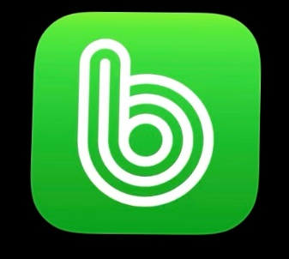

You will have to create yourself a profile first (username and password). Once you've finished, refer to this document to find the links for each page that you will need.

* We have our Short Dance Studios Page (with Short Dance logo). Please click on the link and then click “Join this band”, we will be posting all our information here that pertains to the whole studio.
* Also, each teacher has created a band for themselves. This is where their music and/or videos can be found. This is a good place to communicate with each teacher and other students within your classes if necessary. *Note: Some teachers are still working on uploading their music.
* Here's an example: If your child is enrolled in a class with Ms. Alice or Ms. Kailey, Join their Band page to find their music. If your dancer has multiple teachers, your dancer will be a part of multiple Band pages as each teacher has their own Band Page. The Band App has a main "Home" page that makes it easy to navigate back and forth.

Below are all the links to join each teachers page. You can access the Band app on any device.

**Main Short Dance Studios Page**: [band.us/@shortdance](http://band.us/@shortdance)

**Teacher Pages:**

Jessica: <https://band.us/@jessicashort>

Lydia: <https://band.us/@lydiarutland>

Alice: <https://band.us/@msalice>

Des: <https://band.us/@desiree>

Kailey: <https://band.us/n/a8a03fH6eb59y>

Emily: . <https://band.us/band/85706733>

Brandy: <https://band.us/@sdsnrbrandy>

Kjrsten: <https://band.us/n/afaf6fS6w7k3P>

Izzi: <https://band.us/n/adad66T5Jc79k>

Kayla: . <https://band.us/n/aca261Sbb5U9c>​

Kaylee: Coming Soon

Maddie: <https://band.us/n/aaae69S8w2Oc9>​

Wade: Can be found on the main Short Dance Page

We hope this helps you stay connected and access the music for your dance(s).

Let us know if you have any questions,

Short Dance Studios